Cloud Application Architecture Guide

N-tier architecture on virtual machines
This section describes a recommended N-tier architecture running on VMs.
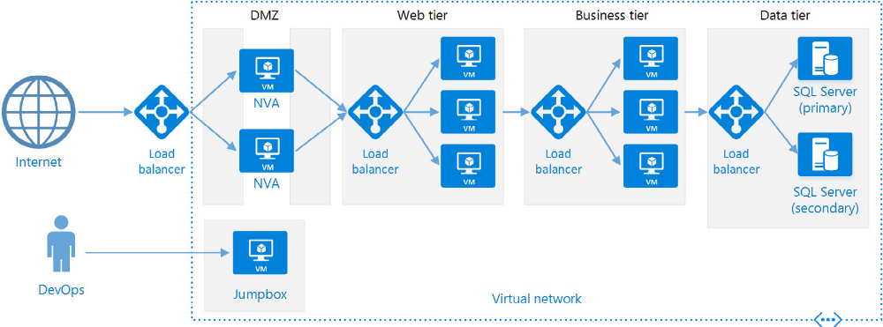

Each tier consists of two or more VMs, placed in an availability set or VM scale set.
Each tier is also placed inside its own subnet, meaning their internal IP address fall within the same address range. That makes it easy to apply network security group (NSG) rules and route tables to individual tiers.
Web / Business tiers are stateless. any VM can handle any request for that tier. The data tier should consist of a replicated database. For Windows , recommend SQL server, using Always On Availability Groups for high availability. For Linux , choose a database that supports replication, such as Apache Cassandra.
NSGs restrict access to each tier. E.g., that database tier only allows access from the business tier.

Linux N-tier application in Azure with Apache Cassandra

https://docs.microsoft.com/en-us/azure/architecture/reference-architectures/n-tier/n-tier-cassandra
This reference architecture shows how to deploy VMs and a virtual network configured for an N-tier application.

Architecture
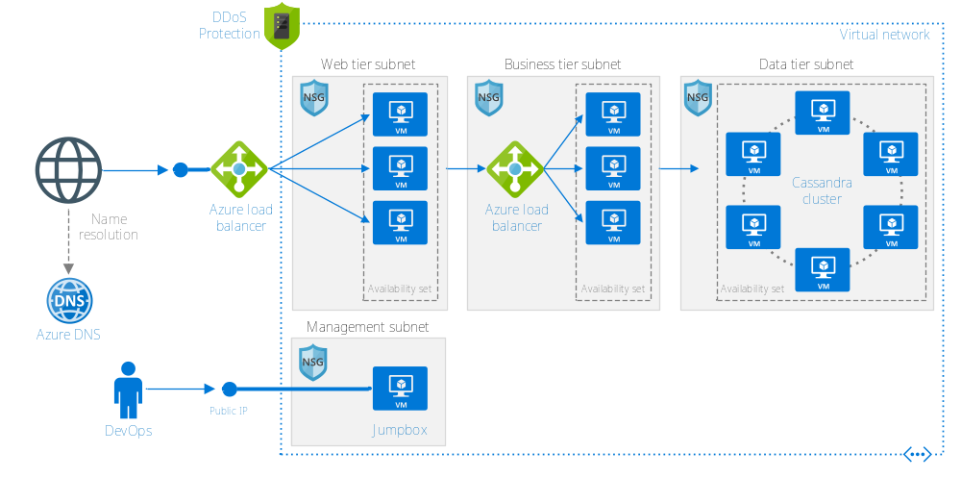
The architecture has the following components:
- Resource group: to group resources so they can be managed by lifetime, owner, or other criteria.
- Virtual network(VNet) and subnets: Every Azure VM is deployed into a VNet that can be segmented into subnets. Create a separate subnet for each tier.
- NSGs: Use network security groups to restrict network traffic within the VNet. For example, in the three-tier architecture shown here, the database tier accepts traffic from the business tier and the management subnet, but not the web front end.
- DDos Protection:
- Virtual machines: refer to
Run a Linux virtual machine on Azure- https://docs.microsoft.com/en-us/azure/architecture/reference-architectures/n-tier/linux-vm
Run a Windows virtual machine on Azure
https://docs.microsoft.com/en-us/azure/architecture/reference-architectures/n-tier/windows-vm
- Availability sets: Create an availability set for each tier, and provision at least two VMs in each tier, which makes the VMs eligible for a higher SLA
- Azure load balancers: The load balancers distribute incoming Internet requests to the VM instances. Use a public load balancer to distribute incoming Internet traffic to the web tier, and an internal load balancer to distribute network traffic from the web tier to the business tier.
- Public IP address: A public IP address is needed for the public load balancer to receive Internet traffic
- Jumpbox: Also called a bastion host. A secure VM on the network that administrators use to connect to the other VMs. The jumpbox has an NSG that allows remote traffic only from public IP addresses on a safe list. The NSG should allow ssh traffic
- Apache Cassandra database: Porvides high availability at the data tier, by enabling replication and failover
- Azure DNS: is a hosting service for DNS domains. It provides name resolution using Microsoft Azure infrastructure. By hosting your domains in Azure, you can manage your DNS records using the same credentials, APIs, and billing as your other Azure services.

Web-Queue-Worker Architecture style

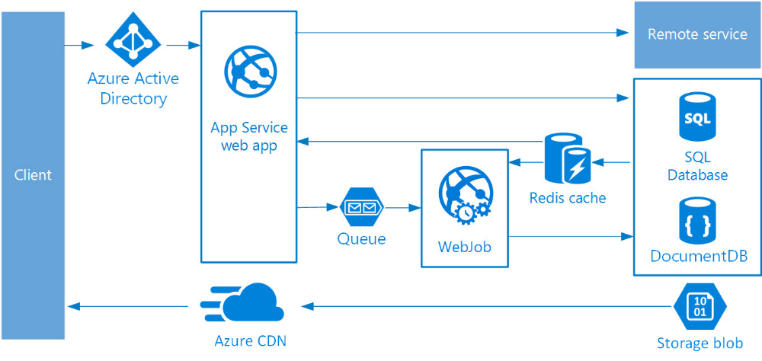

The front end is implemented as an Azure App Service web app, and the worker is implemented as a WebJob. The web app and the WebJob are both associated with an App Service plan that provides the VM instances.

You can use either Azure Service Bus or Azure Storage queues for message Queue.
Azure Redis Cache stores session state and other data that needs low latency access.
Azure CDN is used to cache static content such as images, CSS, or HTML
For storage , choose the storage technologies that best fit the needs of the application. You might use multiple storage technologies (polyglot persistence).

Considerations:

Microservices architecture style
Consists of a collection of small, autonomous services. Each service is self-contained and should implement a single business capability
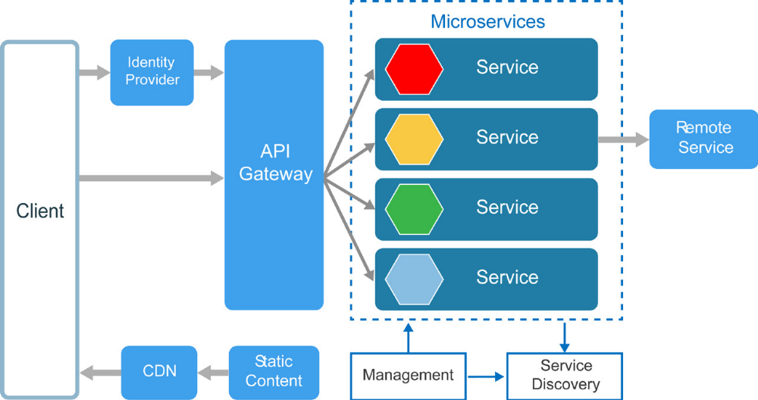

SOA vs microservice
- In a microservice architecture, services are small, independent, and loosely coupled
- Each service is a separate codebase, which can be managed by a small development team
- Services can be deployed independently. A team can update an existing service without rebuilding and redeploying the entire application.
- Services are responsible for persisting their own data or external state. This differs from the traditional model, where a separate data layer handles data persistence
- Services communicate with each other by using well-defined APIs. Internal implementation details of each service are hidden from other services.
- Services don’t need to share the same technology stack, libraries, or frameworks.

Additional components appear in a typical microservices architecture:
- Management
- Service discovery
- API Gateway: advantage of using API

When to use this architecture:

Benefits:

Challenges:
- Complexity, entire system
- Development and test: services dependencies
- Lack of governance: cross-cutting functionality such as logging
- Network congestion and latency:
  - avoid chain of service dependencies getting too long,
  - avoid overly chatty API, think about serialization formats
  - use asynchronous communication patterns
- Data integrity. With each microservice responsible for its own data persistence. As a result, data consistency can be a challenge, Embrace eventual consistency where possible.
- Management: Mature DevOps culture. Typically , logging must correlate multiple service calls for a single user operation
- Versioning
- Skillset

Best practices:
- Model services
- Decentralize everything
- Data storage should be private to the service that owns the data
- Services communicate through well-designed APIs
- Avoid coupling between services
- Offload cross-cutting concerns, such as authentication and SSL termination, to the gateway
- Keep domain knowledge out of the gateway
- Services should have loose coupling and high functional cohesion
- Isolate failures

Microservices using Azure Container Service/Azure Service Fabric

Azure Container Services supports.
Azure container service to configure and provision a Docker cluster. Azure Container Services support several popular container orchestrators, including Kubernetes, DC/OS, AND Docker Swarm | Azure service fabric
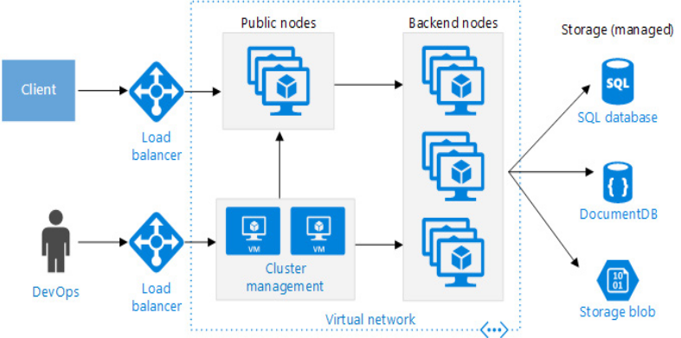 | 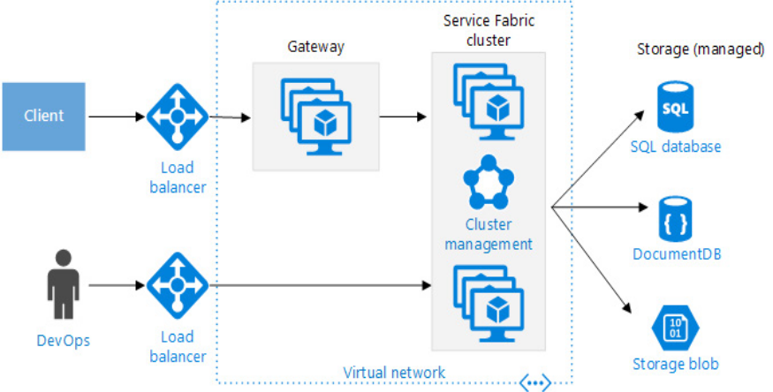
Public nodes: Reachable through a public-facing load balancer, API gateway is hosted on these nodes.  Backend nodes: Run services that clients reach via the API gateway.  Management VMs: run the master nodes for the container orchestrator.  Networking: public nodes, backend nodes and management VMs are placed in separate subnets within the same virtual network(VNet)  Load balancers:1, An externally facing load balancer sits in front of the public nodes. It distributes internet requests to the public nodes. 2, Another load balancer is placed in front of the management VMs, to allow secure shell(ssh) traffic to the management VMs, using NAT rules  Examples: three nodes running 4 different services, each service has at least two instances.  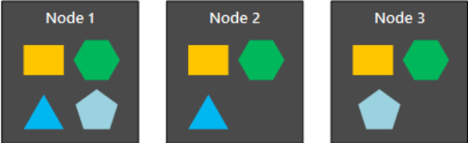 | - The Service Fabric Cluster is deployed to one or more VM scale sets.  - API gateway is placed in front of the Service Fabric cluster, with and external load balancer to receive client requests  - Service Fabric runtime performs cluster management, including service placement, node failover, and health monitoring.  - Services communicate with each other using the reverse proxy that is built into Service Fabric.  - Service Fabric provides a discovery service that can resolve the endpoint for a named service

CQRS architecture style
Separated read operations from write operations
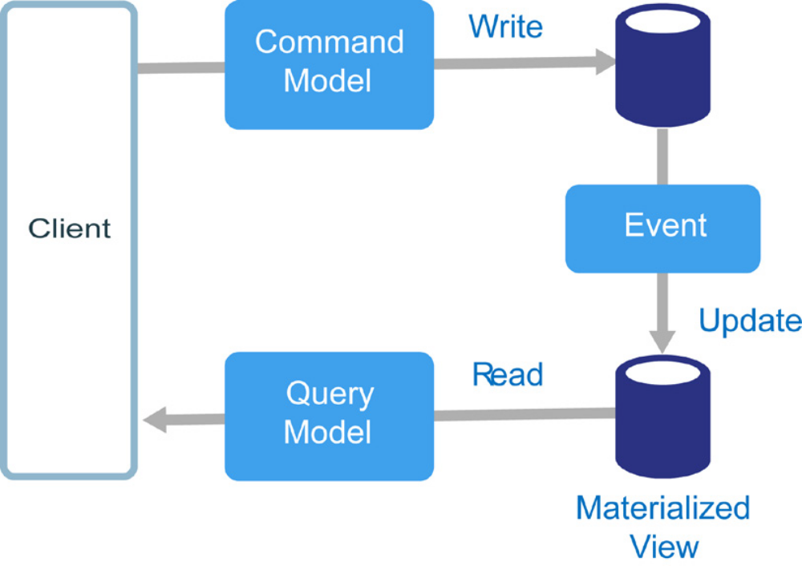
In traditional architectures, the same data model is used to query and update a database. That’s simple and works well for basic CRUD operations.
Complex applications, however, this approach can become unwieldy. On read side, the app may perform many different queries, retruning data transfer objects(DTOs) with different shapes. Object mapping can become complicated.
On the write side, the model may implement complex validation and business logic.
Another potential problem is that read and write workloads are often asymmetrical, with very different performance and scale requirements.

CQRS addresses these problems by separating reads and writes into separate models, using commands to update data, and queries to read data.
- Commands should be task based, rather than data centric. (“Book hotel room”, not “set ReservationStatus to Reserved”). Command may be placed on a queue for asynchronous processing, rather than being processed synchronously.
- Queries never modify the database. A query returns a DTO that does not encapsulate any domain knowledge.
- For greater isolation, can physically separate the read data from the write data. The read database can use its own data schema that is optimized for queries. E.g. it can store a materialized view of the data, in order to avoid complex joins or O/RM mappings.
- Even can use different types of data store, the write database might be relational, while the read database is a document database.
- Keep read and write database in sync, typically this is accomplished by having the write model publish an event whenever it updates the database. Updating the database and publishing the event must occur in a single transaction.
- Event sourcing pattern
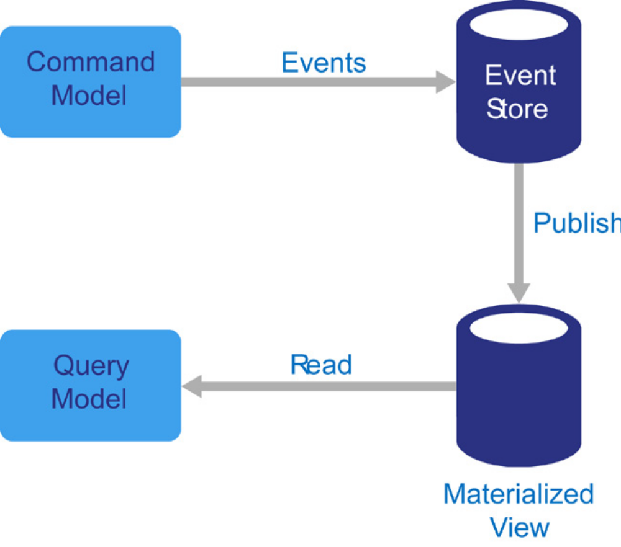

When to use CQRS
Apply CQRS only to those subsystems where there is a clear value in separating reads and writes to an entire system

Benefits
Independently scaling
Optimized data schemas
Security
Separation of concerns
Simpler queries
Challenges:
Complexity
Messaging: it is common to use messaging to process commands and publish update events. In that case, the application must handle message failures or duplicate messages
Eventual consistency: If you separate the read and write databases, the read data may be stale

CRQS in Microservices
One of the principles of microsservices is that a service cannot directly access another service’s data store
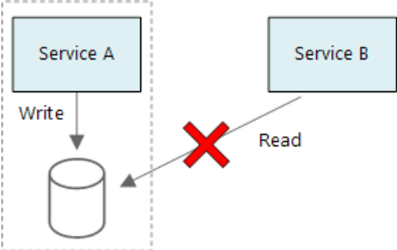
In the following diagram, Service A writes to a data store, and Service B keeps a materialized view of the data. Service A publishes an event whenever it writes to the data store. Service B subscribes to the event.
